Flowchart1::LCD_INIT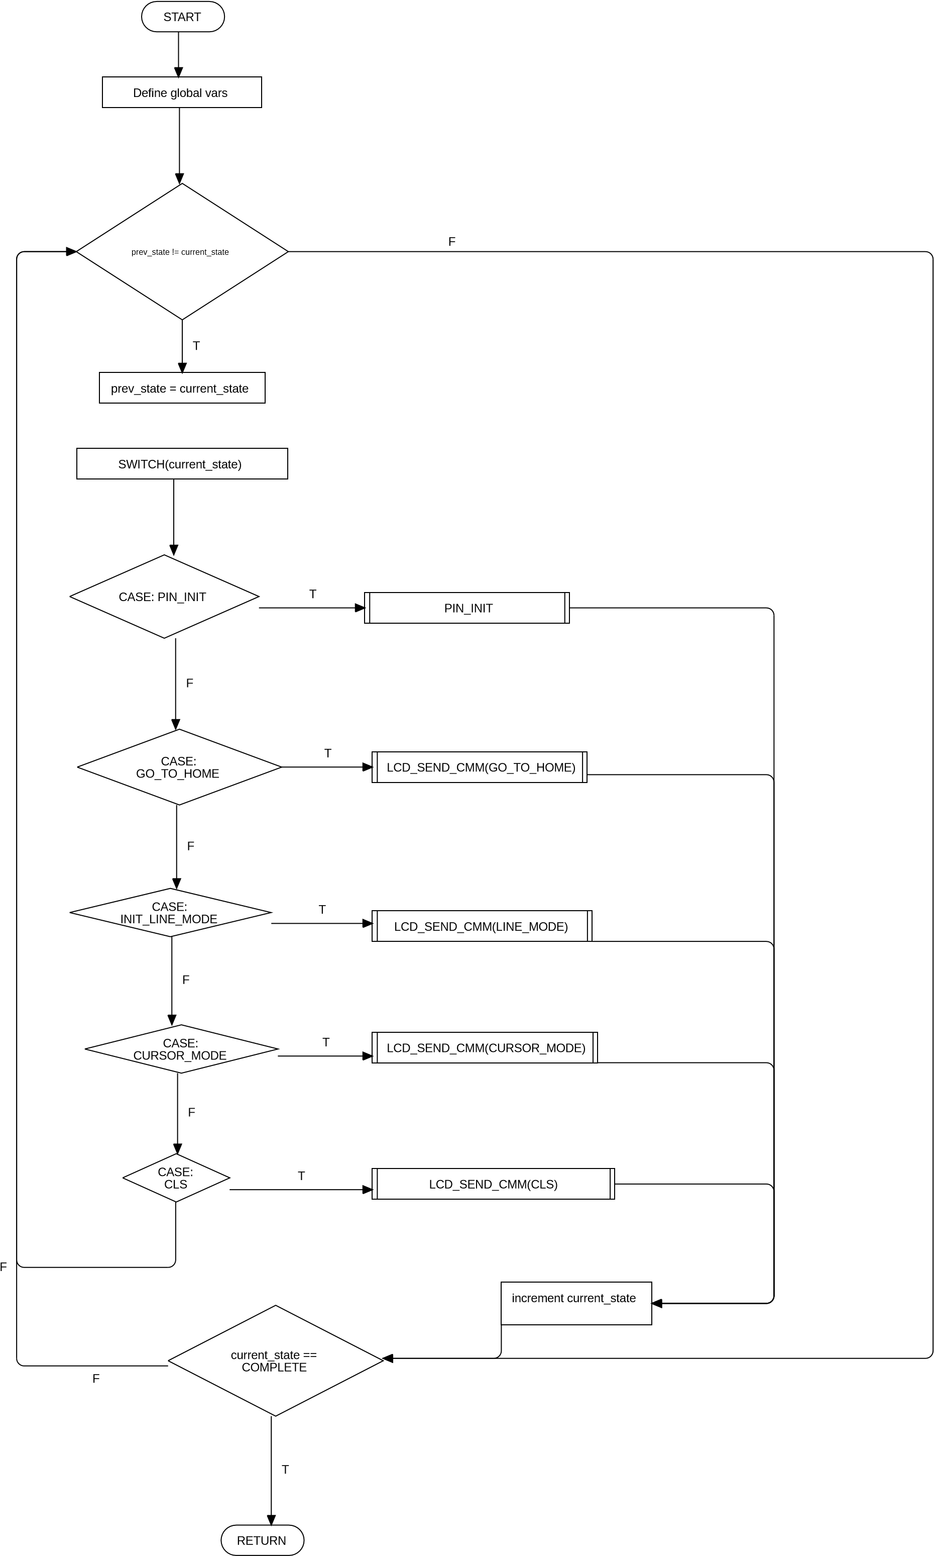

Flowchart2::LCD_SEND_CMM

START

INIT Global vars

current_state !=

prev_state

prev_state = current_sate

T

SWITCH(current_state)

case:

CLEAR_RS_RW

DIO_LOW(RS,RW)

T

case:enable E

F

DIO_HIGH(E)

T

case:

write_date

F

DIO_WRITE_PORT(date)

T

case:

disable E

F

DIO_LOW(E)

T

INCREMENT

current_state

F

current_state

=

COMPLETE

END

T

F

F

Flowchart3::LCD_SEND_CHAR